**Target Journals:**

**Title**:Soil nitrogen availability indirectly modifies leaf nitrogen content through reductions in the unit cost of resource use

**Running Head:** *β* modifies leaf nitrogen content

**Author List:** Evan A. Perkowski, Nicholas G. Smith

**Author Affiliations:** Department of Biological Sciences, Texas Tech University, Lubbock, TX

**Manuscript compilation details**

**Abstract:** XXX words

**Main text word count**: XXX words

Introduction: XXX words

Methods: XXX words

Results: XXX words (not including text in figures or tables)

Discussion: XXX words

**References**: XXX

**Tables and Figures**: XXX

**Supplemental Information**:

**Abstract**

* Variance in leaf nitrogen content across time and space can be predicted through interactions between aboveground growing conditions and soil resource availability. Recent ecophysiological theory suggests that increasing soil nitrogen availability should increase leaf nitrogen content to maintain optimal photosynthetic rates with less efficient nitrogen use and greater water use efficiency, a pattern driven by a reduction in the cost of acquiring and using nitrogen relative to water (*β*). Yet, no study has explicitly measured the effect of *β* on leaf nitrogen content across broad environmental gradients.
* In 2020 and 2021, we measured leaf nitrogen content and leaf carbon isotopes in 520 individuals comprising 57 species across 24 sites scattered across a precipitation and soil nitrogen availability gradient in Texas, USA.
* As expected from theory, variance in leaf nitrogen content across sites was driven by a negative effect of increasing *β*. Increasing soil nitrogen availability also reduced *β* as expected, leading to a marginal indirect positive effect of increasing soil nitrogen availability on leaf nitrogen content
* Our findings support patterns expected from theory, showing that leaf nitrogen content is driven by changes in the cost of acquiring nitrogen relative to water for the first time across a broad environmental gradient.

**Introduction**

Terrestrial biosphere models, which comprise the land surface component of Earth system models, are sensitive to the formulation of photosynthetic processes (Knorr & Heimann, 2001; Ziehn *et al.*, 2011; Booth *et al.*, 2012; Walker *et al.*, 2021). This is because photosynthesis is the largest carbon flux between the atmosphere and terrestrial biosphere, and is constrained by ecosystem carbon and nutrient biogeochemical cycles (Hungate *et al.*, 2003; LeBauer & Treseder, 2008; IPCC, 2013; Fay *et al.*, 2015). Many terrestrial biosphere models formulate photosynthesis by parameterizing photosynthetic capacity within plant functional groups through empirical linear relationships between leaf nitrogen content and the maximum carboxylation rate of Ribulose-1,5-bisphosphate carboxylase/oxygenase (Kattge *et al.*, 2009; Rogers, 2014; Rogers *et al.*, 2017). Models are also beginning to include connected carbon-nitrogen cycles (Davies-Barnard *et al.*, 2020), which allows leaf photosynthesis to be predicted directly through changes in leaf nitrogen content and indirectly through changes in soil nitrogen availability (e.g., LPJ-GUESS, Smith *et al.*, 2014; CLM5.0, Lawrence *et al.*, 2019). Despite recent model developments, open questions remain regarding the generality of ecological relationships between soil nitrogen availability, leaf nitrogen content, and leaf photosynthesis.

Empirical support for positive relationships between soil nitrogen availability and leaf nitrogen content is abundant (Firn *et al.*, 2019; Liang *et al.*, 2020), and is a pattern often attributed to the high nitrogen cost of building and maintaining Rubisco (Evans, 1989; Evans & Seemann, 1989; Onoda *et al.*, 2004, 2017; Walker *et al.*, 2014; Dong *et al.*, 2020). Such patterns might imply that positive relationships between soil nitrogen availability and leaf nitrogen content should yield increased leaf Rubisco concentrations, which could increase the maximum rate of rubisco carboxylation if leaf photosynthesis is limited by the maximum Rubisco carboxylation rate (cite). This integrated leaf nitrogen-photosynthesis response to soil nitrogen availability has been observed both in manipulative experiments (cite) and across broad environmental gradients (cite), and is thought to be driven by ecosystem nitrogen limitation, which limits primary productivity globally (LeBauer & Treseder, 2008; Fay *et al.*, 2015). However, this response is not consistently observed across studies, as recent studies note variable leaf nitrogen-photosynthesis relationships across soil nitrogen availability gradient (Waring *et al.*; Liang *et al.*, 2020; Luo *et al.*, 2021) and that aboveground growing conditions (e.g., light availability) may be more important for explaining variance in leaf nitrogen content or photosynthetic capacity across broad environmental gradients than soil nitrogen availability (Dong *et al.*, 2017, 2020; Smith *et al.*, 2019; Peng *et al.*, 2021; Westerband *et al.*, 2022). Thus, there is a need to resolve conditions where soil nitrogen availability and aboveground growing conditions either individually or interactively affect leaf nitrogen content.

One hypothesized mechanism to explain variance in leaf nitrogen content across soil resource availability and climate gradients has been proposed through recent photosynthetic least-cost theoretical frameworks (Wright *et al.*, 2003; Prentice *et al.*, 2014; Paillassa *et al.*, 2020; Harrison *et al.*, 2021). The theory predicts that plants acclimate to environments by maximizing photosynthetic carbon gain at the lowest summed cost of nutrient and water use (‘unit cost ratio’ or ‘*β*’ from this point forward; Wright *et al.*, 2003; Prentice *et al.*, 2014). Nutrient and water use can be substituted for each other to maintain the lowest summed cost, such that a given optimal photosynthesis rate can be achieved with less efficient use of a more abundant resource and more efficient use of a less abundant resource. Thus, the theory predicts that an increase in soil nitrogen availability, assuming all else equal, should decrease *β* and result in a stimulation of leaf nitrogen content at lower stomatal conductance. This response is predicted to result in optimal photosynthetic rates achieved with less efficient nitrogen use and more efficient water use (Wright *et al.*, 2003).

While photosynthetic least-cost theory provides a useful hypothesis for primary drivers of leaf nitrogen content, empirical tests of the theory are sparse. Previous work has shown that changes in soil nitrogen availability can induce predictable nutrient-water use tradeoffs expected from theory across broad environmental gradients (Paillassa *et al.*, 2020; Querejeta *et al.*, 2022; Westerband *et al.*, 2022) and finer spatial resolution manipulation experiments (Perkowski *et al.* in prep; Bialic‐Murphy *et al.*, 2021). However, no study to date has investigated these patterns using the *β* as a direct predictor of variance in leaf nitrogen content and tradeoffs between nitrogen and water use. The lack of such studies limit our ability to detect whether these tradeoffs are directly driven through changes in soil resource availability and aboveground growing conditions, or if these patterns are indirectly driven by changes in *β*.

In summer 2020 and 2021, we measured leaf nitrogen content and estimated *β* using carbon isotopic signatures of 520 individuals spanning 57 species scattered across 24 grassland sites in Texas, USA (Table S1). Texas contains a diverse climatic gradient, indicated by 2006-2020 mean annual precipitation totals ranging from 204 to 1803 mm, mean annual temperature ranging from 11.8° to 24.6°C, and mean annual vapor pressure deficit ranging from 0.59 to 2.29 kPa within the state boundary. Variability in soil nitrogen availability was also expected across sites, owing to differences in soil texture and aboveground climate that would drive differential rates of nitrogen transformations to plant-available forms in the soil. We leveraged the climatic and expected edaphic variability across Texas to test the following hypotheses related to photosynthetic least cost theory:

1. Increasing soil nitrogen availability will decrease *β*. This will result in direct negative effects of increasing *β* on leaf nitrogen content, and an indirect positive effect of increasing soil nitrogen availability on leaf nitrogen content through reductions in *β*. We also expected limited direct effects of increasing soil nitrogen availability on leaf nitrogen content, which would correspond with reductions in stomatal conductance.
2. Increasing soil moisture will increase *β*. This will result in an indirect reduction in leaf nitrogen content and water use efficiency through a direct negative effect of increasing *β* on leaf nitrogen content. We also expected limited direct negative effects of increasing soil moisture on leaf nitrogen content, corresponding with a stimulation in stomatal conductance.
3. Effects of soil nitrogen availability and soil moisture on *β* will depend on species photosynthetic pathway and ability to acquire nitrogen through associations with symbiotic nitrogen-fixing bacteria. Specifically, we expect species that form associations with symbiotic nitrogen-fixing bacteria and C4 species to have less responsive changes in *β* across the soil nitrogen availability and soil moisture gradient, demonstrating weaker changes in leaf nitrogen content and water use efficiency than expected in species not capable of forming associations with symbiotic nitrogen-fixing bacteria or C3 species.

**Methods**

*Site descriptions and sampling methodology*

We collected leaf and soil samples from 24 sites scattered across central and eastern Texas in summer 2020 and summer 2021 (Fig. 1). Twelve sites were visited between June and July 2020 and 14 sites (11 unique from 2020) were visited between May and June 2021 (Table 1). We explicitly chose sites that maximized climatic and edaphic variability between sites and contained dominant open savanna or grassland components (Table 1). Any site with personally communicated or anecdotal evidence of grazing or disturbance (e.g., mowing, feral hog activity, etc.) was excluded from our analysis. At each site, we collected leaf material from three individuals each of the five most abundant species at random locations in the property. All collected leaves were fully expanded with no visible herbivory or damage and free from shading by nearby shrubs or trees. Five soil samples were collected from 0-15cm below the soil surface at random locations in the property. Soil samples were mixed together by hand to create one composite soil sample per site.

*Leaf trait measurements*

Images of each leaf were taken immediately following each site visit using a flat-bed scanner. Fresh leaf area was determined from each image using the 'LeafArea' R package (Katabuchi, 2015), which automates leaf area calculations using ImageJ software (Schneider *et al.*, 2012). Each leaf was then dried at 65C for at least 48 hours, weighed, and manually ground in a mortar and pestle until homogenized. Leaf mass per area (*M*area; g m-2) was calculated as the ratio of fresh leaf area to dry leaf biomass. Subsamples of dried and homogenized leaf tissue were used to measure leaf nitrogen content (*N*mass; gN g-1) through elemental combustion analysis (Costech-4010, Costech Instruments, Valencia, CA). Leaf nitrogen content per unit leaf area (*N*area; gN m-2) was then calculated as the product of *N*mass and *M*area.

Subsamples of dried and homogenized leaf tissue were also sent to the University of California-Davis Stable Isotope Facility to determine leaf δ13C. Leaf δ13C values were determined using an elemental analyzer (PDZ Europa ANCA-GSL; Sercon Ltd., Chestshire, UK) interfaced to an isotope ratio mass spectrometer (PDZ Europa 20-20 Isotope Ratio Mass Spectrometer, Sercon Ltd., Chestshire, UK). We used leaf δ13C values (‰; relative to VDDB) to estimate the ratio of intercellular (*C*i) to extracellular (*C*a) CO2 (χ; unitless) following the approach of Farquhar *et al.* (1989) described in Cernusak *et al.* (2013). We derived χ as:

(Eqn. 1)

Δ13C represents the relative difference between leaf δ13C (‰) and air δ13C (‰), and is calculated from the following equation:

$Δ^{13}C=\frac{δ^{13}C_{air}-δ^{13}C_{leaf}}{1+δ^{13}C_{leaf}}$ (Eqn. 2)

where δ13Cair is assumed to be -8‰ (Keeling *et al.*, 1979; Farquhar *et al.*, 1989), *a* represents the fractionation between 12C and 13C due to diffusion in air, assumed to be 4.4‰, and *b* represents the fractionation caused by Rubisco carboxylation, assumed to be 27‰ (Farquhar *et al.*, 1989). For C4 species, *b* in Eqn. 1 was set to 6.3‰, and was derived from:

$b=c+(dφ)$ (Eqn. 3)

Where c was set to -5.7‰ and d was set to 30‰ (Farquhar *et al.*, 1989). φ, which is the bundle sheath leakiness term, was set to 0.4. All χ values less than 0.2 and greater than 1.0 were removed.

We derived the unit cost of resource use (*β*) using leaf χ and site climatic data with equations first described in Prentice et al. (2014) and simplified in Lavergne *et al.* (2020):

$β=1.6η^{*}D\frac{{\left(χ-\frac{Γ^{*}}{C_{a}}\right)}^{2}}{{\left(1-χ\right)}^{2}∙(K+Γ^{*})}$ (Eqn. 4)

η* is the viscosity of water relative to 25ºC, calculated using elevation and mean air temperature of the seven days leading up to each site visit following equations in Huber *et al.* (2009). D represents vapor pressure deficit (Pa), set to the mean vapor pressure deficit of the seven days leading up to each site visit, *C*a represents atmospheric CO2 concentration, arbitrarily set to 420 μmol mol-1 CO2. K (Pa) is the Michaelis-Menten coefficient for Rubisco affinity to CO2 and O2, calculated as:

$K=K_{c}\left(1+\frac{O_{i}}{K_{o}}\right)$ (Eqn. 5)

where Kc (Pa) and *K*o (Pa) are the Michaelis-Menten coefficients for Rubisco affinity to CO2 and O2, respectively, and Oi is the intercellular O2 concentration. Γ* (Pa) is the CO2 compensation point in the absence of dark respiration. *K*c, *K*o, and *Γ*\* were determined using equations described in Medlyn *et al.* (2002) and derived in Bernacchi *et al.* (2001), invoking an elevation correction to convert parameters to Pa as done in Lavergne *et al.* (2020) and Smith *et al.* (2019).

**Table 1** Site locality information, sampling year(s), 2006-2020 mean annual precipitation (MAP; mm), mean annual temperature (MAT; °C), and mean annual vapor pressure deficit (MAV; kPa). Rows are arranged by longitude to visualize precipitation variability across sites*

|  |  |  |  |  |  |  |
| --- | --- | --- | --- | --- | --- | --- |
| **Property** | **Latitude** | **Longitude** | **Sampling year** | **MAP** | **MAT** | **MAV** |
| Edwards_2019_17 | 29.95 | -100.36 | 2020 | 563.5 | 19.0 | 1.21 |
| Uvalde_2020_02 | 29.59 | -100.09 | 2020, 2021 | 648.5 | 19.5 | 1.23 |
| Menard_2020_01 | 30.91 | -99.57 | 2020 | 641.9 | 18.3 | 1.29 |
| Kerr_2020_03 | 30.06 | -99.34 | 2021 | 672.4 | 18.3 | 1.19 |
| Bandera_2020_03 | 29.85 | -99.30 | 2021 | 789.4 | 18.8 | 1.22 |
| Sansaba_2020_01 | 31.29 | -98.62 | 2020 | 733.0 | 18.8 | 1.26 |
| Comal_2020_21 | 29.79 | -98.43 | 2020 | 878.5 | 19.9 | 1.21 |
| Blanco_2019_16 | 29.99 | -98.43 | 2020 | 833.0 | 19.2 | 1.15 |
| Bexar_2019_13 | 29.24 | -98.43 | 2020 | 759.3 | 21.5 | 1.33 |
| Burnet_2020_14 | 30.84 | -98.34 | 2021 | 763.3 | 19.5 | 1.24 |
| Comal_2020_19 | 30.01 | -98.32 | 2021 | 845.0 | 19.3 | 1.15 |
| Hays_2021_54 | 29.96 | -98.17 | 2021 | 861.3 | 20.0 | 1.17 |
| Burnet_2020_12 | 30.82 | -98.06 | 2021 | 815.1 | 19.4 | 1.17 |
| Williamson_2019_09 | 30.71 | -97.86 | 2020 | 867.7 | 19.7 | 1.18 |
| Williamson_2019_10 | 30.54 | -97.77 | 2020 | 819.5 | 19.9 | 1.20 |
| Bell_2021_08 | 31.06 | -97.55 | 2021 | 937.3 | 19.6 | 1.20 |
| Fayette_2021_12 | 29.86 | -97.21 | 2021 | 985.7 | 20.4 | 1.12 |
| Fayette_2019_04 | 30.09 | -96.78 | 2020 | 1017.4 | 20.6 | 1.10 |
| Fayette_2020_09 | 29.86 | -96.71 | 2021 | 1002.7 | 20.8 | 1.10 |
| Washington_2020_08 | 30.28 | -96.41 | 2021 | 1077.4 | 20.4 | 1.08 |
| Austin_2020_03 | 29.78 | -96.24 | 2021 | 1108.7 | 20.6 | 1.01 |
| Brazos_2020_16 | 30.93 | -96.23 | 2021 | 1078.0 | 20.1 | 1.09 |
| Brazos_2020_18 | 30.52 | -96.21 | 2020, 2021 | 1099.4 | 20.4 | 1.12 |
| Harris_2020_03 | 29.88 | -95.31 | 2020, 2021 | 1492.0 | 21.6 | 1.00 |

**Figure 1**



**Figure 1** Maps that detail site locations along 2006-2020 mean annual precipitation (panel A) and mean annual temperature (panel B) gradients in Texas, USA. Precipitation and temperature data were plotted at a 4-km grid resolution and are masked to include only grid cells that occur in the Texas state boundary in the United States. In both panels, open circles refer to sites visited in 2020, open triangles to sites visited in 2021, and closed circles to sites visited in 2020 and 2021. The scale bar in panel A applies to both panels.

*Site climate data*

We used the Parameter-elevation Regressions on Independent Slopes Model (PRISM; Daly *et al.*, 2008) climate product to access gridded daily temperature and precipitation data for the coterminous United States at a 4-km grid resolution between January 1, 1991 and July 31, 2021 (PRISM Climate Group, Oregon State University, <https://prism.oregonstate.edu>, data created 4 Feb 2014, accessed 24 Mar 2022). Daily mean air temperature, mean vapor pressure deficit, and total precipitation data were extracted from the grid cell that contained the latitude and longitude of each property using the ‘extract’ function in the ‘terra’ R package (Hijmans, 2022). PRISM data were used in lieu of local weather station data because several rural sites did not have a local weather station present within a 20-km radius of the property. Daily site climate data were used to estimate mean annual precipitation, mean annual temperature, and mean annual vapor pressure deficit for each site between 2006 and 2020 (Table 1). We then iteratively calculated total precipitation, mean daily air temperature, and mean daily vapor pressure deficit for the prior 1, 2, 3, 4, 5, 6, 7, 8, 9, 10, 15, 20, 25, 30, 60, and 90 days leading up to each site visit.

*Site edaphic characteristics*

Composite soil samples were sent to the Texas A&M Soil, Water and Forage Laboratory to quantify macronutrient concentrations, pH, and electrical conductivity. Soil nitrate-nitrogen (NO3-N; ppm) was extracted in 1 M KCl and measured spectrophotometrically at 520 nm through the end product of a NO3-N to NO2-N cadmium reduction reaction (Keeney & Nelson, 1983; Kachurina *et al.*, 2000). Soil phosphorus and potassium were extracted in a solution containing 0.2 N acetic acid, 0.25 N ammonium nitrate, 0.015 N ammonium fluoride, 0.013 N nitric acid, and 0.001 N EDTA (Mehlich, 1984). Soil pH was measured in a 1:2 soil: deionized water slurry after a 30-minute incubation period at room temperature with a hydrogen selective electrode. Electrical conductivity was similarly measured in a 1:2 soil: deionized water slurry after a 30-minute incubation period at room temperature with a conductivity probe (Rhoades, 1983). Soil NO3-N concentration was chosen as the primary indicator of site soil nutrient availability, as NO3-N concentrations had strong positive correlations with soil phosphorus concentration (Pearson’s r=0.44, p=0.006; Fig. S1) and electrical conductivity (Pearson’s r=0.74, p<0.001; Fig. S1). There was no correlation between soil NO3-N concentration and soil pH (Pearson’s r=-0.02, p=0.908; Fig. S1) or soil potassium concentration (Pearson’s r=0.04, p=0.819; Fig. S1).

Soil moisture was not measured in the field, but was estimated using the ‘Simple Process-Led Algorithms for Simulating Habitats’ model ('SPLASH'; Davis *et al.*, 2017). This model, derived from the STASH model (Cramer & Prentice, 1988), spins up a bucket model that calculates daily soil moisture (*W*n; mm) as a function of the previous day’s soil moisture (*W*n-1; mm), daily precipitation (*P*n; mm), condensation (*C*n; mm), actual evapotranspiration ($E_{n}^{a}$; mm), and runoff (RO; mm):

$W_{n}=W_{n-1}+P_{n}+C_{n}-E_{n}^{a}-RO$ (Eqn. 6)

This equation is solved on a daily timestep using a 150mm bucket depth (Cramer & Prentice, 1988) by first equilibrating the previous day’s soil moisture using successive model iterations with daily mean air temperature, precipitation, the number of daily sunlight hours, and latitude as model inputs to estimate daily solar radiation, condensation, evapotranspiration, and runoff using equations explained in Cramer & Prentice (1988) and Davis *et al.* (2017). Daily sunlight hours were estimated for each day at each site using the ‘getSunlightTimes’ function in the ‘suncalc’ R package, which estimated sunrise and sunset times of each property using date and site coordinates (Thieurmel & Elmarhraoui, 2019). We used daily soil moisture outputs from the SPLASH model for each site to iteratively calculate mean daily soil moisture for the prior 1, 2, 3, 4, 5, 6, 7, 8, 9, 10, 15, 20, 25, 30, 60, and 90 days leading up to each site visit. This was done to determine relevant climatic timescales that best explained *β* and *χ*. Soil moisture values are expressed in this study as a fraction of bucket depth, as done in Stocker *et al.* (2018).

*Plant functional group assignments*

Plant functional group was assigned to each species and used as the primary descriptor of species identity. Specifically, we assigned plant functional groups based on photosynthetic pathway (C3, C4) and ability to form associations with symbiotic nitrogen-fixing bacteria. The ability to form associations with symbiotic nitrogen-fixing bacteria was assigned based on whether species were in the *Fabaceae* family, and identified photosynthetic pathway confirmed through leaf δ13C values. We chose these plant functional groups based on *a priori* hypotheses regarding the functional role of nitrogen fixation and photosynthetic capacity on leaf nitrogen content and stomatal conductance. These plant functional group classifications resulted in three distinct plant functional groups within our dataset: C3 legumes (n=53), C3 non-legumes(n=350), and C4 non-legumes (n=117).

*Data analysis*

We constructed a series of separate linear mixed-effects models to investigate environmental drivers of *β*, *χ*, and *N*area. Then, we constructed a path analysis using structural equation modeling to investigate primary direct and indirect pathways that drove variance in *N*area.

To explore environmental drivers of *β*, we built a linear mixed effect model that included soil moisture, soil nitrogen availability, and plant functional group as fixed effect coefficients. Species were designated as a random intercept term. Interaction coefficients between all possible combinations of the three fixed effect coefficients were also included. *β* was natural log transformed to linearize data. We used an information-theoretic model selection approach to determine whether 90-, 60-, 30-, 20-, 15-, 10-, 9-, 8-, 7-, 6-, 5-, 4-, 3-, 2-, or 1-day mean daily soil moisture conferred the best model fit for *β*. To do this, we constructed 16 separate linear mixed-effects models where *β* was included as the response variable and each soil moisture timestep was separately included as a single continuous fixed effect. Species were included as a random intercept term for all models. We used corrected Akaike Information Criterion (AICc) to select the soil moisture timescale that conferred the best model fit, indicated by the model with the lowest AICc score (Table S2; Fig. S2).

To explore environmental drivers of *χ*, we constructed two separate linear mixed effects models. In the first model, we included mean daily air temperature, vapor pressure deficit, *β*, and plant functional group as fixed effect coefficients. We also included two-way interaction terms between plant functional group and daily air temperature, vapor pressure deficit, or *β*. Species were designated as a random intercept term. Because *χ* is an input into the calculation of *β*, and is therefore autocorrelated with *β*, we constructed a second linear mixed effects model that included daily air temperature, vapor pressure deficit, soil moisture, soil nitrogen availability, and plant functional group as fixed effect coefficients. We also included all possible interactions between soil moisture, soil NO3-N availability, and plant functional group, and two-way interactions between plant functional group and daily air temperature or vapor pressure deficit as additional fixed effect coefficients. For both models, we used an information-theoretic model selection approach to determine whether 90-, 60-, 30-, 20-, 15-, 10-, 9-, 8-, 7-, 6-, 5-, 4-, 3-, 2-, or 1-day mean daily air temperature and vapor pressure deficit conferred the best model fit for *χ* using the same approach explained for the model investigating the relevant soil moisture timescale for *β*. In the second model, we used the same soil moisture timescale as was determined the best fit for *β*.

To explore environmental drivers of *N*area, we constructed two separate linear mixed effects models. The first linear mixed effect model included soil nitrogen availability, *β*, *χ*, and plant functional group as fixed effect coefficients, with species again designated as a random intercept term. Two-way interactions between plant functional group and soil nitrogen availability, *β*, or *χ* were also included. The second linear mixed effect model substituted soil moisture for *β* to replicate the structure of the linear mixed effect model used to explain variance in *β* and avoid autocorrelation between *β* and *χ*. Two-way interactions between plant functional group and soil nitrogen availability, soil moisture, or *χ* were included, in addition to a two-way interaction between soil moisture and soil nitrogen availability and a three-way interaction between soil moisture, soil nitrogen availability, and plant functional group.

Finally, we conducted a path analysis using a structural equation model to examine direct and indirect pathways that determined variance in *N*area. The path analysis included plant functional group, soil nitrogen availability, *β*, and *χ* as direct predictors of *N*area. Vapor pressure deficit, air temperature, and plant functional group were included as direct predictors of *χ*. Soil moisture, soil nitrogen availability, and plant functional group were included as direct predictors of *β*. We also included soil moisture as a direct predictor of soil nitrogen availability, air temperature as a direct predictor of vapor pressure deficit, and *β* as a covariate of *χ* (see Eq. 4). Finally, indirect effects of soil nitrogen availability on *N*area through *β*, indirect effects of soil moisture on *N*area through *β*, and indirect effects of soil moisture on *N*area through soil nitrogen availability and *β* were included in the structural equation model fit. All variables except for plant functional group were scaled and centered using the ‘scale’ function in base R prior to structural equation model loading (R Core Team, 2021).

In all linear mixed-effects models, including those to select relevant aridity timescales, we used the 'lmer' function in the 'lme4' R package (Bates *et al.*, 2015) to fit each model and the 'Anova' function in the 'car' R package (Fox & Weisberg, 2019) to calculate Type II Wald's χ2 and determine the significance level (α=0.05) of each fixed effect coefficient. We also used the 'emmeans' R package (Lenth, 2019) to conduct post-hoc comparisons using Tukey's tests, where degrees of freedom were approximated using the Kenward-Roger approach (Kenward & Roger, 1997). The structural equation model was build using the ‘sem’ function in the ‘lavaan’ R package (Rosseel, 2012). All analyses and plots were conducted in R version 4.1.1 (R Core Team, 2021). Trendlines and error ribbons for all plots were drawn using a series of ‘emmean’ outputs across the range in x-axis values.

**Results**

*Unit cost ratio (β)*

Model selection indicated that 3-day soil moisture was the timescale that conferred the best model fit for *β* (Table S2; Fig. S2).

Variance in *β* across sites was driven by a strong two-way interaction between soil moisture and plant functional group (Table 2), which indicated a negative effect of increasing soil moisture on *β* in C4 non-legumes (Tukey: p=0.001) and no effect of soil moisture in C3 legumes (Tukey: p=0.641) and non-legumes (Tukey: p=0.415; Fig. 2A). We also found a strong negative effect of increasing soil nitrogen availability on *β* (Table 2; Fig. 2B), a pattern observed across all plant functional groups. Finally, C4 non-legumes generally had lower *β* values than both C3 legumes (Tukey: p=0.005) and C3 non-legumes (Tukey: p<0.001) when averaged across soil moisture and soil nitrogen availability values.

**Table 2** Effects of soil moisture, soil nitrogen availability, and plant functional group on *β*\*

|  |  |  |  |  |
| --- | --- | --- | --- | --- |
|  | df | Coefficient | χ2 | *P*-value |
| Intercept | - | 3.78E+00 | - | - |
| Soil moisture (SM) | 1 | 1.44E+01 | 11.500 | **<0.001** |
| Soil N (N) | 1 | -2.13E-02 | 10.712 | **0.001** |
| PFT | 2 | - | 64.314 | **<0.001** |
| SM * N | 1 | 1.28E+00 | 0.064 | 0.801 |
| SM * PFT | 2 | - | 32.405 | **<0.001** |
| N * PFT | 2 | - | 3.274 | 0.195 |
| SM * N * PFT | 2 | - | 0.038 | 0.981 |

*Significance determined using Type II Wald χ2 tests (α=0.05). *P*-values less than 0.05 are in bold. Slopes and standard error values, represented on the natural-log scale, are averaged over plant functional groups, and are only included for individual continuous fixed effects. Key: df=degrees of freedom, χ2=Wald Type II chi-square test statistic

**Figure 2**

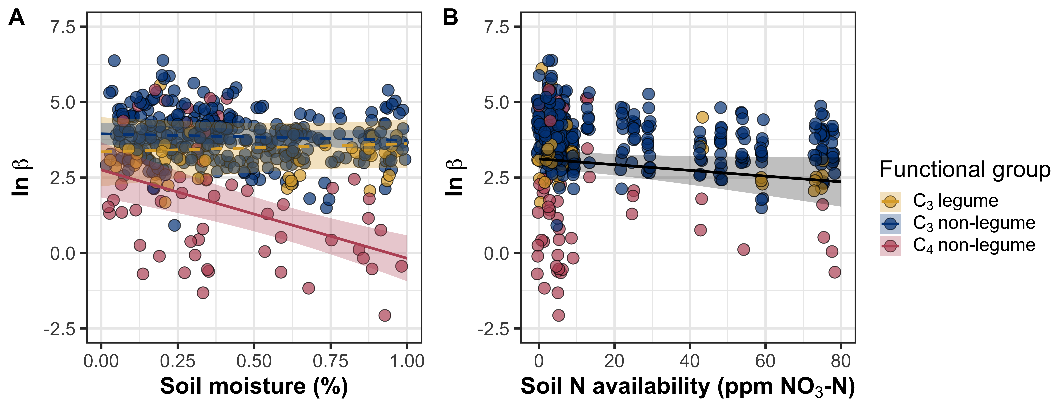

**Fig. 2** Effects of soil moisture (panel A) and soil nitrogen availability (panel B) on the unit cost ratio *β*. Yellow shaded points and trendlines indicate C3 legumes, red shaded points and trendlines indicate C4 non-legumes, and blue shaded points and trendlines indicate C3 non-legumes. Points are jittered for visibility. Black trendlines indicate the bivariate relationship between the individual fixed effect listed on the x-axis and response variable on the y-axis and are only included if there was no two-way interaction between the variable listed on the x-axis and plant functional group. Solid trendlines indicate relationships where p<0.05, while dashed trendlines indicate relationships where p>0.05. Error ribbons represent upper and lower 95% confidence intervals of each fitted trendline.

*Chi*

Model selection indicated that 4-day mean daily vapor pressure deficit and 4-day mean daily air temperature were the timescales that conferred the best model fit for *χ* (Table S1; Fig. S2).

When the unit cost ratio was included as a direct predictor of *χ*, *χ* was driven by a series of two-way interactions between plant functional group and 4-day vapor pressure deficit, 4-day air temperature, or the unit cost ratio *β* (Table 3). Specifically, the two-way interaction between functional group and *β* revealed that, while increasing *β* increased *χ* across all functional groups, *χ* in C4 non-legumes was less sensitive to changes in *β* than C3 nonlegumes and C3 legumes (Tukey: p<0.001 in both cases). An additional two-way interaction between plant functional group and vapor pressure deficit indicated that increasing vapor pressure deficit increased χ in C4 nonlegumes (Tukey: p=0.002), decreased χ in C3 nonlegumes (Tukey: p<0.001), and did not change χ in C3 legumes (Tukey: p=0.271). A final two-way interaction between functional group and 4-day air temperature indicated that increasing air temperature increased χ in C4 nonlegumes (Tukey: p=0.002) and C3 legumes (Tukey: p=0.013) but did not influence χ in C3 nonlegumes (Tukey: p=0.509).

Similar patterns were observed when *β* was substituted for soil moisture and soil nitrogen availability (Table 3). Specifically, a two-way interaction between plant functional group and 3-day soil moisture indicated a negative effect of increasing soil moisture on χ in C4 nonlegumes (Tukey: p<0.001), with no apparent effect of soil moisture on χ in C3 legumes (Tukey: p=0.689) or C3 nonlegumes (Tukey: p=0.731; Figure 3A). A weak two-way interaction between functional group and soil nitrogen availability indicated a marginal positive effect of increasing soil nitrogen availability on C4 nonlegumes (Tukey: p=0.082), with again no apparent effect on χ in C3 legumes (Tukey: p=0.401) and C3 nonlegumes (Tukey: p=0.849; Fig. 3B). A two-way interaction between functional group and 4-day vapor pressure deficit indicated the similar patterns as observed from the previous model, where increasing 4-day vapor pressure deficit increased χ in C4 nonlegumes (Tukey: p=0.002), decreased χ in C3 nonlegumes (Tukey: p<0.001), and did not change χ in C3 legumes (Tukey: p=0.262; Fig. 3C). Finally, a two-way interaction between functional group and 4-day air temperature indicated that increasing air temperature increased χ in C4 nonlegumes (Tukey: p<0.001) and C3 legumes (Tukey: p=0.027) but did not influence χ in C3 nonlegumes (Tukey: p=0.427; Fig. 3D).

**Table 3** Analysis of variance results exploring effects of vapor pressure deficit, temperature, the unit cost ratio, drivers of the unit cost ratio, and plant functional group on χ*

|  |  |  |  |  |  |  |  |
| --- | --- | --- | --- | --- | --- | --- | --- |
|  |  | χ with β | | | χ without β | | |
| Treatment | df | Coefficient | χ2 | *P*-value | Coefficient | χ2 | *P*-value |
| Intercept | - | 4.57E-01 | - | - | 4.45E-01 | - | - |
| VPD | 1 | -8.23E-02 | 30.895 | **<0.001** | -1.29E-01 | 10.890 | **<0.001** |
| Temperature (T) | 1 | 2.00E-02 | 0.607 | 0.436 | - | 3.430 | *0.064* |
| Unit cost ratio (*β*) | 1 | 5.24E-04 | 320.499 | **<0.001** | - | - | - |
| Soil moisture | 1 | - | - | - | -2.35E+00 | 17.503 | **<0.001** |
| Soil N | 1 | - | - | - | -1.40E-03 | 1.209 | 0.272 |
| PFT | 2 | - | 136.940 | **<0.001** | - | 87.142 | **<0.001** |
| SM * N | 1 | - | - | - | 2.46E-01 | 0.441 | 0.507 |
| VPD * PFT | 2 | - | 21.965 | **<0.001** | - | 24.786 | **<0.001** |
| T * PFT | 2 | - | 9.855 | **0.007** | - | 42.059 | **<0.001** |
| *β* * PFT | 2 | - | 212.769 | **<0.001** | - | - | - |
| SM * PFT | 2 | - | - | - | - | 56.680 | **<0.001** |
| N * PFT | 2 | - | - | - | - | 9.128 | **0.010** |
| SM * N * PFT | 2 | - | - | - | - | 0.464 | 0.793 |

*Significance determined using Type II Wald χ2 tests (α=0.05). *P*-values less than 0.05 are in bold and 0.05<*P*<0.1 are italicized. The set of model coefficients, χ2 values, and *P* values on the left indicate results from a linear mixed-effect model where the unit cost ratio is included as a predictor of χ. The rightmost set of model coefficients, χ2 values, and *P* values indicate a linear mixed-effect model where the unit cost ratio is substituted for soil nitrogen availability and soil moisture, mimicking the structure of the model used to detect predictors of the unit cost ratio in Table 2. χ was not transformed prior to model fitting, so model coefficients are on the response scale.

**Figure 3**

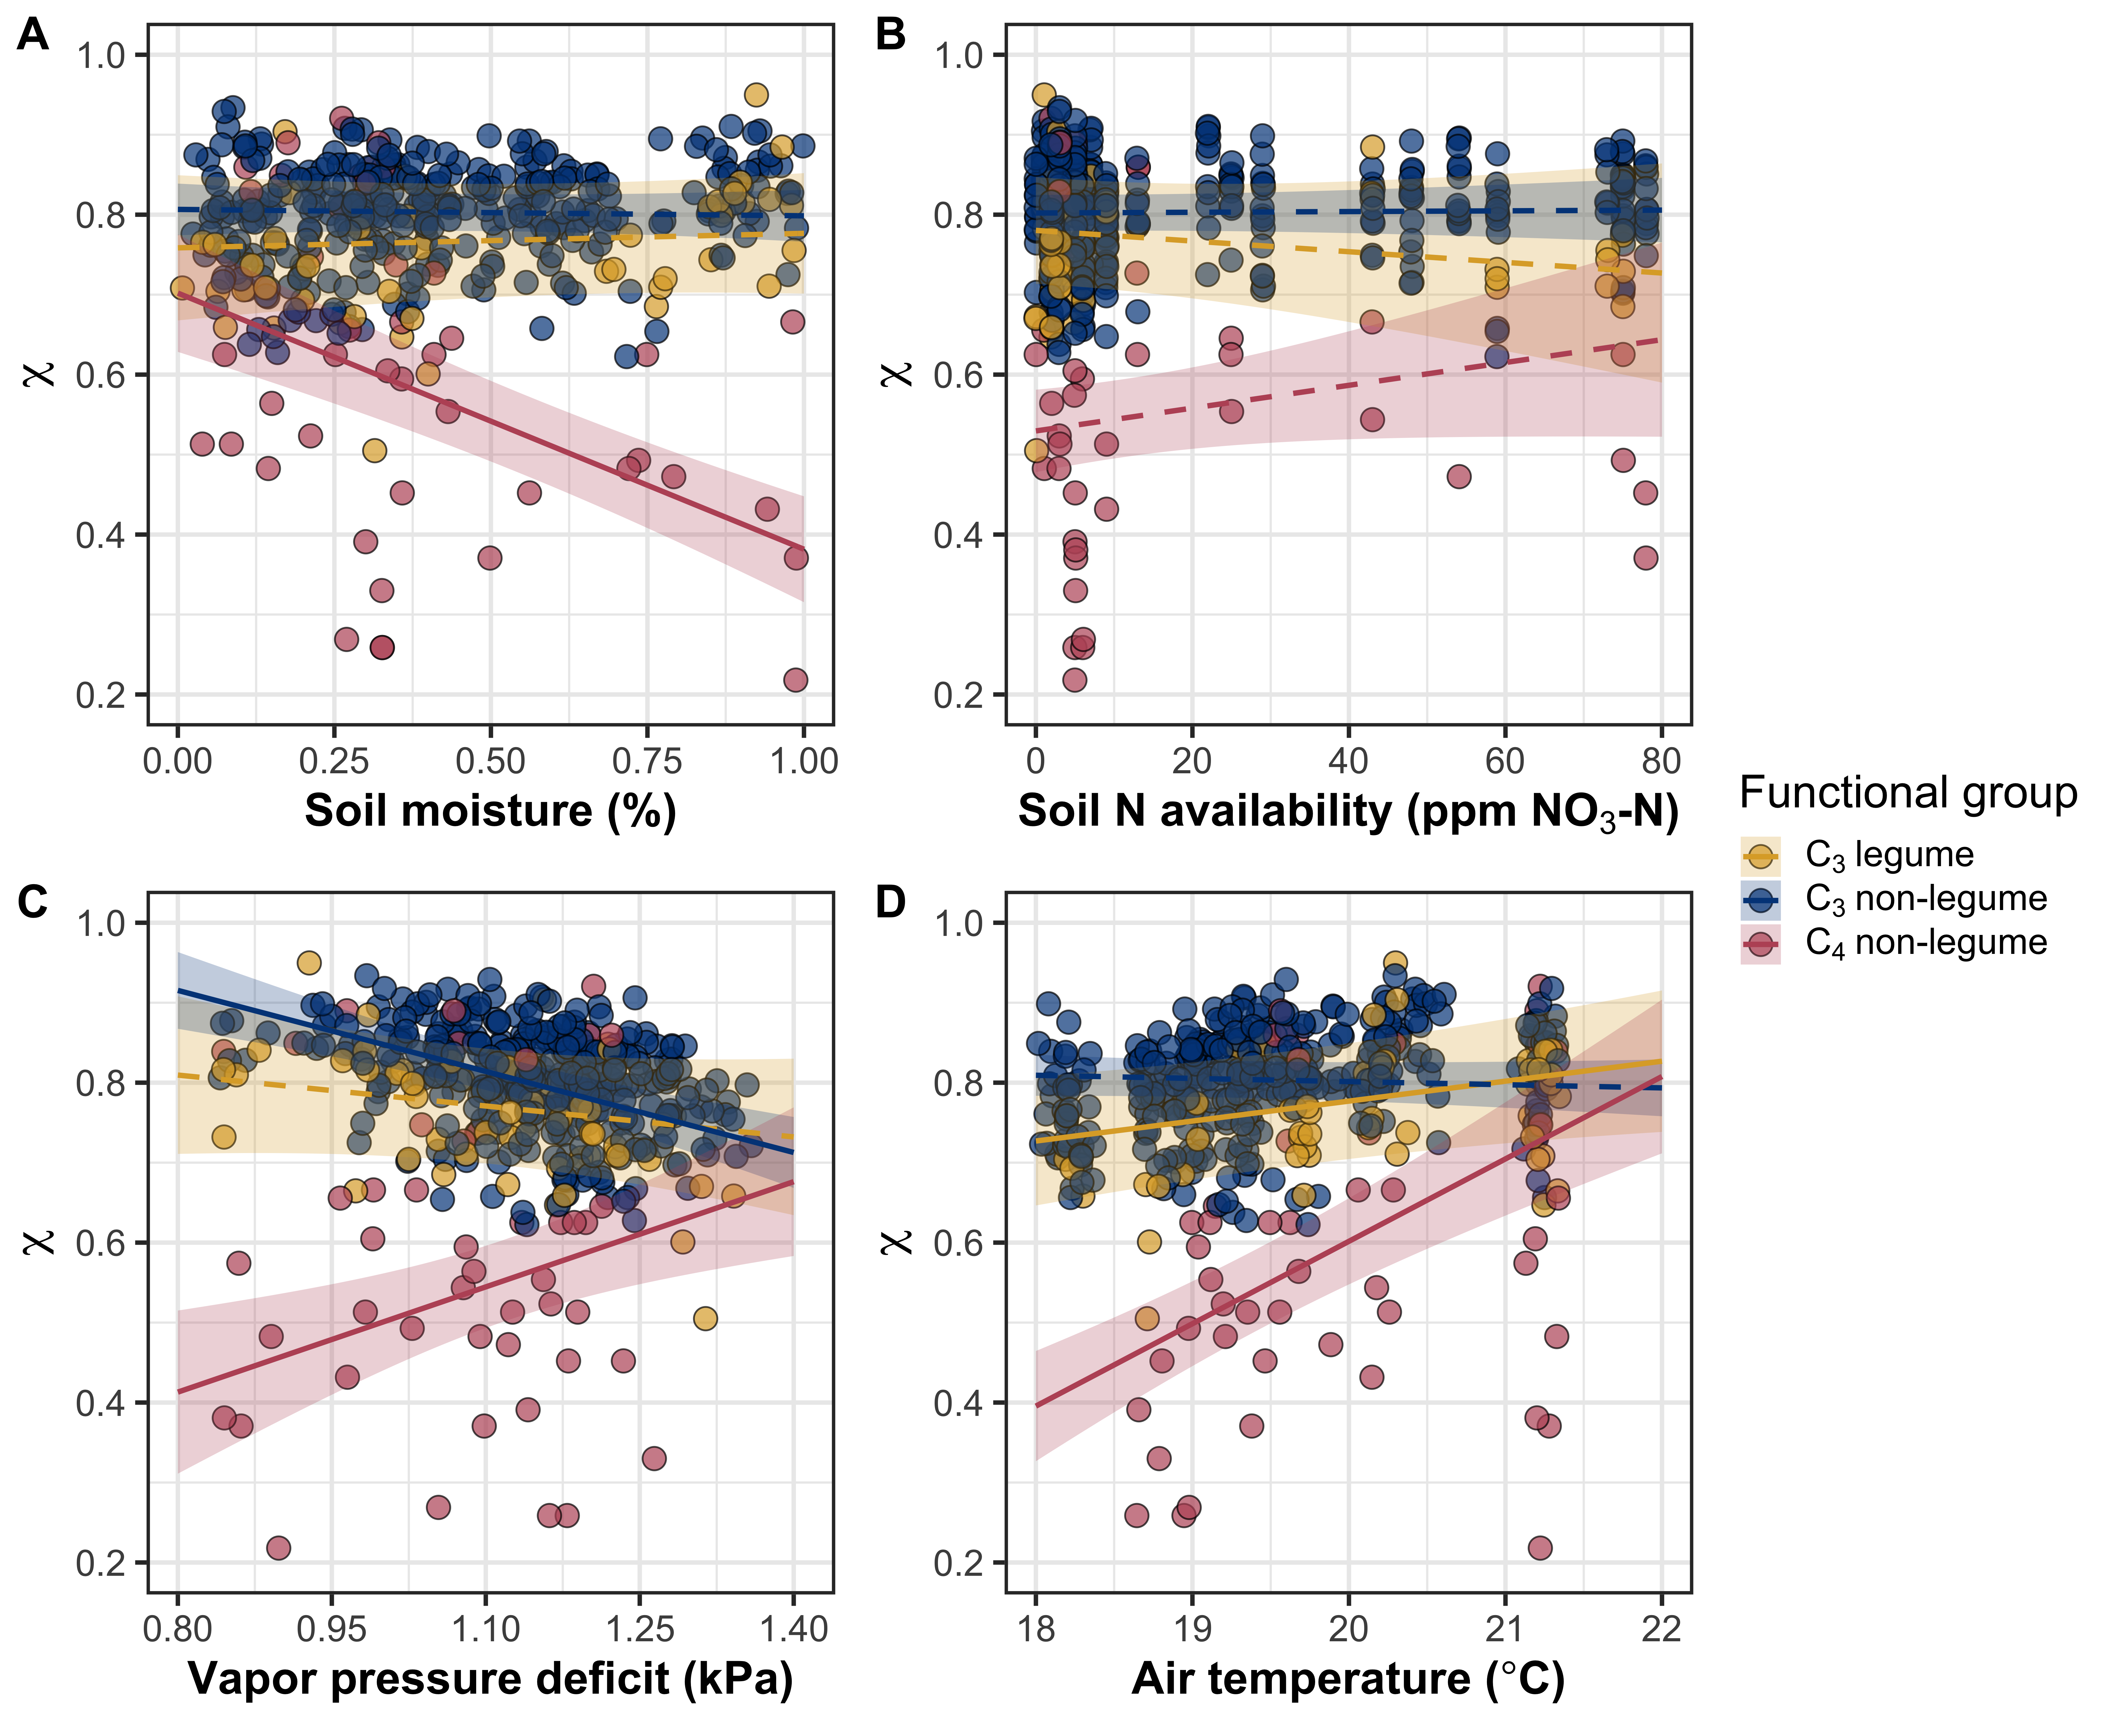

**Fig. 3** Effects of soil moisture (panel A), soil nitrogen availability (panel B), 4-day mean vapor pressure deficit (panel C), and 4-day mean daily air temperature (panel D) on *χ*. Yellow shaded points and trendlines indicate C3 legumes, red shaded points and trendlines indicate C4 non-legumes, and blue shaded points and trendlines indicate C3 non-legumes. Points are jittered for visibility. Solid trendlines indicate relationships where *P*<0.05, while dashed trendlines indicate relationships where *P*>0.05. In all panels, trendlines were extracted from the linear mixed effects model that did not include the unit cost ratio *β* as a fixed effect coefficient.

*Leaf nitrogen content*

When the unit cost ratio *β* was included in our linear mixed effects model, variance in *N*area was driven by a two-way interaction between *β* and plant functional group (Table 4). This interaction indicated a negative effect of increasing *β* on *N*area in C3 legumes (Tukey: p=0.002), a marginal negative effect of increasing *β* on *N*area in C3 nonlegumes (Tukey: p=0.083), and no effect of *β* on *N*area in C4 nonlegumes (Tukey: p=0.244; Fig. 4A). When averaged across plant functional groups, there was a general negative effect of increasing *β* on *N*area (Table 4). We found no distinguishable of *χ* on *N*area but did observe a marginal positive effect of increasing soil nitrogen availability on *N*area (Table 4; Fig. 4B). There was no observable interaction between plant functional group and *χ* or soil nitrogen availability (Table 4).

When *β* was substituted for soil moisture and soil nitrogen availability in our linear mixed-effects model, variance in *N*area was driven by a two-way interaction between plant functional group and *χ* (Table 4). This interaction indicated a negative effect of increasing *χ* on *N*area in C3 non-legumes (Tukey: p<0.001), with no apparent effect of *χ* on *N*area in C3 legumes (Tukey: p=0.143) or C4 non-legumes (Tukey: p=0.658). Variance in *N*area could also be attributed to a two-way interaction between soil moisture and soil nitrogen availability, which indicated that the general positive effect of soil nitrogen availability on *N*area (Table 4) decreased with increasing soil moisture. There was no observable individual effect of soil moisture on *N*area, nor was there any two-way interaction between plant functional group and soil nitrogen availability or soil moisture (Table 4). We also found no evidence for a three-way interaction between soil nitrogen availability, soil moisture, and plant functional group (Table 4).

**Table 4** Analysis of variance results exploring effects of soil nitrogen availability, the unit cost ratio, χ, and plant functional group on *N*area*

|  |  |  |  |  |  |  |  |
| --- | --- | --- | --- | --- | --- | --- | --- |
|  |  | *N*area with *β* | | | *N*area without *β* | | |
|  | df | Coefficient | χ2 | P-value | Coefficient | χ2 | P-value |
| Intercept | - | 6.49E-01 | - | - | 1.79E+00 | - | - |
| Unit cost ratio (*β*) | 1 | -2.91E-03 | 9.944 | **0.002** | - | - | - |
| *χ* | 1 | 7.97E-01 | 0.673 | 0.412 | -1.06E+00 | 5.444 | **0.020** |
| Soil N (N) | 1 | 3.04E-03 | 2.174 | 0.140 | 1.63E-02 | 3.695 | *0.055* |
| Soil moisture (SM) | 1 | - | - | - | 4.78E+01 | 0.014 | 0.907 |
| PFT | 2 | - | 44.242 | **<0.001** | - | 58.791 | **<0.001** |
| SM * N | 1 | - | - | - | -2.60E+00 | 5.993 | **0.014** |
| *β* * PFT | 2 | - | 5.943 | *0.051* | - | - | - |
| *χ* * PFT | 2 | - | 6.259 | **0.044** | - | 16.604 | **<0.001** |
| N * PFT | 2 | - | 1.690 | 0.429 | - | 1.966 | 0.374 |
| SM * PFT | 2 | - | - | - | - | 0.738 | 0.691 |
| SM * N * PFT | 2 | - | - | - | - | 2.277 | 0.320 |

*Significance determined using Type II Wald χ2 tests (α=0.05). *P*-values less than 0.05 are in bold and 0.05<*P*<0.1 are italicized. Coefficients are expressed on natural-log scale, as *N*area was natural log transformed prior to model fitting

**Figure 4**

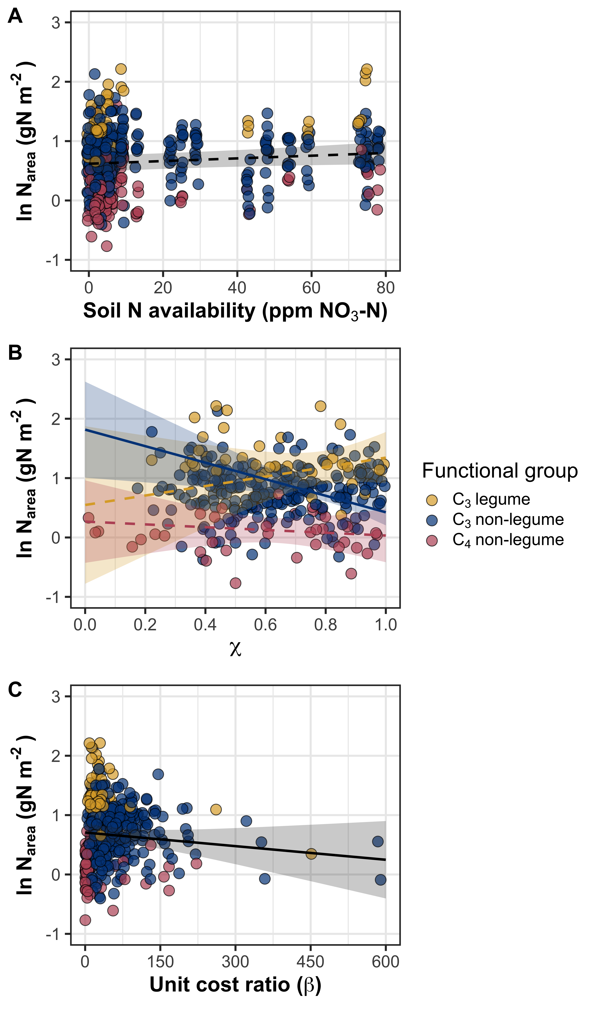

**Fig. 4** Effects of soil nitrogen availability (panel A), *χ* (panel B), and the unit cost ratio *β* (panel C) on leaf nitrogen content per unit leaf area. Yellow shaded points and trendlines indicate C3 legumes, red shaded points and trendlines indicate C4 non-legumes, and blue shaded points and trendlines indicate C3 non-legumes. Black trendlines indicate the bivariate relationship between the individual fixed effect listed on the x-axis and response variable on the y-axis and are only included if there was no observable two-way interaction between the variable listed on the x-axis and plant functional group. Solid trendlines indicate relationships where p<0.05, while dashed trendlines indicate relationships where p>0.05. Trendlines for both panels were drawn using the linear mixed effects model that included the unit cost ratio.

*Structural equation model*

Results from the structural equation model (Table 5; Fig. 5) suggested similar results as the series of linear mixed effects models. While variability in *N*area was largely driven by plant functional group (p<0.001), *N*area was also driven by a direct negative effect of increasing *β* (p=0.046). There was no direct effect of *χ* (p=0.570) or soil nitrogen availability (p=0.392) on *N*area. However, increasing soil nitrogen availability had a strong negative effect on *β* (p<0.001), which led to a marginal positive indirect effect of increasing soil nitrogen availability on *N*area through *β* (p=0.077). Soil moisture had a weak marginal negative direct effect on *β* (p=0.083), but no indirect effect on *N*area through *β* (p=0.191). Interestingly, we found that increasing soil moisture had a robust positive effect on soil nitrogen availability (p<0.001), which contributed to a rather weak marginal positive effect of soil moisture on *N*area indirectly through soil nitrogen availability and *β* (p=0.079).

Despite a strong negative effect of increasing 4-day mean air temperature on 4-day mean vapor pressure deficit (p<0.001), there was no apparent direct effect of air temperature (p=0.672) or vapor pressure deficit (p=0.423) on *χ*. Instead, variance in *χ* was driven by plant functional group (p<0.001) and highly covaried with *β* (p<0.001).

**Table 5** Path analysis results investigating direct and indirect drivers of leaf nitrogen content*

|  |  |  |  |  |
| --- | --- | --- | --- | --- |
|  | **Dependent variable** | **Slope [LCI, UCI]** | **z-score** | **p-value** |
| *N*area | |  |  |  |
|  | *β* | -0.129 [-0.256, -0.002] | -1.993 | **0.046** |
|  | *χ* | -0.039 [-0.174, 0.096] | -0.568 | 0.570 |
|  | Soil N | 0.046 [-0.059, 0.150] | 0.856 | 0.392 |
|  | Plant functional group | -1.515 [-1.744, -1.286] | -12.977 | **<0.001** |
|  | Soil N\**β* (indirect) | 0.023 [-0.002, 0.048] | 1.769 | *0.077* |
|  | SM\**β* (indirect) | 0.010 [-0.005, 0.026] | 1.308 | 0.191 |
|  | SM*Soil N\**β* (indirect) | 0.012 [-0.001, 0.026] | 1.754 | *0.079* |
| *β* | |  |  |  |
|  | SM | -0.080 [-0.170, 0.010] | -1.733 | *0.083* |
|  | Soil N | -0.176 [-0.266, -0.086] | -3.837 | **<0.001** |
|  | Plant functional group | -0.052 [-0.243, 0.138] | -0.538 | 0.591 |
| *χ* | |  |  |  |
|  | *VPD* | -0.037 [-0.127, 0.053] | -0.802 | 0.423 |
|  | Air temperature | 0.019 [-0.070, 0.109] | 0.423 | 0.672 |
|  | Plant functional group | -0.775 [-0.955, -0.523] | -8.460 | **<0.001** |
| *VPD* | |  |  |  |
|  | Air temperature | -0.597 [-0.672, -0.523] | -15.690 | **<0.001** |
| Soil N | |  |  |  |
|  | SM | 0.544 [0.428, 0.623] | 13.395 | **<0.001** |
| *β* | |  |  |  |
|  | *χ* (covariate) | 0.528 [0.428, 0.628] | 10.353 | **<0.001** |

*P-values less than 0.05 in bold, while P-values between 0.05 and 0.10 are italicized. Key: LCI=lower 95% confidence interval, UCI=upper 95% confidence interval, *N*area=leaf nitrogen content per unit leaf area; *β*=unit cost ratio; *χ*=isotope-derived estimate of the leaf *C*i:*C*a ratio, SM=soil moisture

**Figure 5**

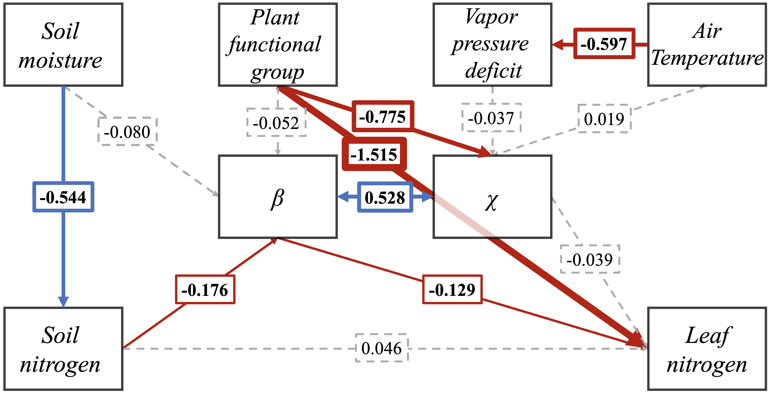

**Figure 5** Structural equation model results exploring direct and indirect drivers of leaf nitrogen content per unit leaf area. Boxes indicate measured edaphic factors, climatic factors, and leaf traits. Blue solid arrows indicate positively correlated bivariate relationships (p<0.05), red solid arrows indicate negatively correlated bivariate relationships (p<0.05), and grey dashed lines indicate no correlation between bivariate relationships (p>0.05). A double-sided arrow is included between *β* and χ to note their inclusion in the structural equation model as covariates.

Numbers indicate model estimates of each bivariate relationship, noted in bold fond when the correlation between the bivariate relationship occurs at p<0.05. Arrow thickness scales with the absolute value of the model estimate.

**Discussion**

Widespread evidence exists documenting positive relationships between soil nutrient availability, leaf nutrient content, and leaf photosynthesis (cite). However, recent work indicates that variance in leaf nitrogen content are best predicted through interactions between aboveground climatic drivers and belowground edaphic factors, and that aboveground growing conditions explain more variance in leaf nitrogen content than soil nitrogen availability.

Our findings suggest that leaf nitrogen content was driven by a shift in the unit cost ratio of resource use (β) and was not driven by direct changes in stomatal conductance or soil resource availability.

**References**

**Bates D, Mächler M, Bolker B, Walker S**. **2015**. Fitting linear mixed-effects models using lme4. *Journal of Statistical Software* **67**: 1–48.

**Bernacchi CJ, Singsaas EL, Pimentel C, Portis AR, Long SP**. **2001**. Improved temperature response functions for models of Rubisco-limited photosynthesis. *Plant, Cell and Environment* **24**: 253–259.

**Bialic‐Murphy L, Smith NG, Voothuluru P, McElderry RM, Roche MD, Cassidy ST, Kivlin SN, Kalisz S**. **2021**. Invasion‐induced root–fungal disruptions alter plant water and nitrogen economies (M Rejmanek, Ed.). *Ecology Letters* **24**: 1145–1156.

**Booth BBB, Jones CD, Collins M, Totterdell IJ, Cox PM, Sitch S, Huntingford C, Betts RA, Harris GR, Lloyd J**. **2012**. High sensitivity of future global warming to land carbon cycle processes. *Environmental Research Letters* **7**: 024002.

**Cernusak LA, Ubierna N, Winter K, Holtum JAM, Marshall JD, Farquhar GD**. **2013**. Environmental and physiological determinants of carbon isotope discrimination in terrestrial plants. *New Phytologist* **200**: 950–965.

**Cramer W, Prentice IC**. **1988**. Simulation of regional soil moisture deficits on a European scale. *Norsk Geografisk Tidsskrift - Norwegian Journal of Geography* **42**: 149–151.

**Daly C, Halbleib M, Smith JI, Gibson WP, Doggett MK, Taylor GH, Curtis J, Pasteris PP**. **2008**. Physiographically sensitive mapping of climatological temperature and precipitation across the conterminous United States. *International Journal of Climatology* **28**: 2031–2064.

**Davies-Barnard T, Meyerholt J, Zaehle S, Friedlingstein P, Brovkin V, Fan Y, Fisher RA, Jones CD, Lee H, Peano D, *et al.*** **2020**. Nitrogen cycling in CMIP6 land surface models: progress and limitations. *Biogeosciences* **17**: 5129–5148.

**Davis TW, Prentice IC, Stocker BD, Thomas RT, Whitley RJ, Wang H, Evans BJ, Gallego-Sala A V, Sykes MT, Cramer W**. **2017**. Simple process-led algorithms for simulating habitats (SPLASH v.1.0): robust indices of radiation, evapotranspiration and plant-available moisture. *Geoscientific Model Development* **10**: 689–708.

**Dong N, Prentice IC, Evans BJ, Caddy-Retalic S, Lowe AJ, Wright IJ**. **2017**. Leaf nitrogen from first principles: field evidence for adaptive variation with climate. *Biogeosciences* **14**: 481–495.

**Dong N, Prentice IC, Wright IJ, Evans BJ, Togashi HF, Caddy-Retalic S, McInerney FA, Sparrow B, Leitch E, Lowe AJ**. **2020**. Components of leaf‐trait variation along environmental gradients. *New Phytologist* **228**: 82–94.

**Evans JR**. **1989**. Partitioning of nitrogen between and within leaves grown under different irradiances. *Functional Plant Biology* **16**: 533.

**Evans JR, Seemann JR**. **1989**. The allocation of protein nitrogen in the photosynthetic apparatus: costs, consequences, and control. *Photosynthesis* **8**: 183–205.

**Farquhar GD, Ehleringer JR, Hubick KT**. **1989**. Carbon isotope discrimination and photosynthesis. *Annual Review of Plant Physiology and Plant Molecular Biology* **40**: 503–537.

**Fay PA, Prober SM, Harpole WS, Knops JMH, Bakker JD, Borer ET, Lind EM, MacDougall AS, Seabloom EW, Wragg PD, *et al.*** **2015**. Grassland productivity limited by multiple nutrients. *Nature Plants* **1**: 15080.

**Firn J, McGree JM, Harvey E, Flores-Moreno H, Schütz M, Buckley YM, Borer ET, Seabloom EW, La Pierre KJ, MacDougall AS, *et al.*** **2019**. Leaf nutrients, not specific leaf area, are consistent indicators of elevated nutrient inputs. *Nature Ecology & Evolution* **3**: 400–406.

**Fox J, Weisberg S**. **2019**. *An R companion to applied regression*. Thousand Oaks, California: Sage.

**Harrison SP, Cramer W, Franklin O, Prentice IC, Wang H, Brännström Å, de Boer H, Dieckmann U, Joshi J, Keenan TF, *et al.*** **2021**. Eco-evolutionary optimality as a means to improve vegetation and land-surface models. *New Phytologist* **231**: 2125–2141.

**Hijmans RJ**. **2022**. terra: Spatial Data Analysis.

**Huber ML, Perkins RA, Laesecke A, Friend DG, Sengers J V, Assael MJ, Metaxa IN, Vogel E, Mareš R, Miyagawa K**. **2009**. New international formulation for the viscosity of H2O. *Journal of Physical and Chemical Reference Data* **38**: 101–125.

**Hungate BA, Dukes JS, Shaw MR, Luo Y, Field CB**. **2003**. Nitrogen and climate change. *Science* **302**: 1512–1513.

**IPCC**. **2013**. *Climate Change 2013: The Physical Science Basis. Contribution of Working Group I to the Fifth Assessment Report of the Intergovernmental Panel on Climate Change*.

**Kachurina OM, Zhang H, Raun WR, Krenzer EG**. **2000**. Simultaneous determination of soil aluminum, ammonium- and nitrate- nitrogen using 1 M potassium chloride. *Communications in Soil Science and Plant Analysis* **31**: 893–903.

**Katabuchi M**. **2015**. LeafArea: An R package for rapid digital analysis of leaf area. *Ecological Research* **30**: 1073–1077.

**Kattge J, Knorr W, Raddatz T, Wirth C**. **2009**. Quantifying photosynthetic capacity and its relationship to leaf nitrogen content for global-scale terrestrial biosphere models. *Global Change Biology* **15**: 976–991.

**Keeling CD, Mook WG, Tans PP**. **1979**. Recent trends in the 13C/12C ratio of atmospheric carbon dioxide. *Nature* **277**: 121–123.

**Keeney DR, Nelson DW**. **1983**. Nitrogen—Inorganic Forms. In: Page AL, ed. Methods of Soil Analysis. Madison, WI, USA: ASA and SSSA, 643–698.

**Kenward MG, Roger JH**. **1997**. Small sample inference for fixed effects from restricted maximum likelihood. *Biometrics* **53**: 983.

**Knorr W, Heimann M**. **2001**. Uncertainties in global terrestrial biosphere modeling: 1. A comprehensive sensitivity analysis with a new photosynthesis and energy balance scheme. *Global Biogeochemical Cycles* **15**: 207–225.

**Lavergne A, Sandoval D, Hare VJ, Graven H, Prentice IC**. **2020**. Impacts of soil water stress on the acclimated stomatal limitation of photosynthesis: Insights from stable carbon isotope data. *Global Change Biology* **26**: 7158–7172.

**Lawrence DM, Fisher RA, Koven CD, Oleson KW, Swenson SC, Bonan G, Collier N, Ghimire B, Kampenhout L, Kennedy D, *et al.*** **2019**. The Community Land Model Version 5: description of new features, benchmarking, and impact of forcing uncertainty. *Journal of Advances in Modeling Earth Systems* **11**: 4245–4287.

**LeBauer DS, Treseder K**. **2008**. Nitrogen limitation of net primary productivity. *Ecology* **89**: 371–379.

**Lenth R**. **2019**. emmeans: estimated marginal means, aka least-squares means.

**Liang X, Zhang T, Lu X, Ellsworth DS, BassiriRad H, You C, Wang D, He P, Deng Q, Liu H, *et al.*** **2020**. Global response patterns of plant photosynthesis to nitrogen addition: A meta‐analysis. *Global Change Biology* **26**: 3585–3600.

**Luo X, Keenan TF, Chen JM, Croft H, Prentice IC, Smith NG, Walker AP, Wang H, Wang R, Xu C, *et al.*** **2021**. Global variation in the fraction of leaf nitrogen allocated to photosynthesis. *Nature Communications* **12**: 4866.

**Medlyn BE, Dreyer E, Ellsworth DS, Forstreuter M, Harley PC, Kirschbaum MUF, Le Roux X, Montpied P, Strassemeyer J, Walcroft A, *et al.*** **2002**. Temperature response of parameters of a biochemically based model of photosynthesis. II. A review of experimental data. *Plant, Cell & Environment* **25**: 1167–1179.

**Mehlich A**. **1984**. Mehlich 3 soil test extractant: A modification of Mehlich 2 extractant. *Communications in Soil Science and Plant Analysis* **15**: 1409–1416.

**Onoda Y, Hikosaka K, Hirose T**. **2004**. Allocation of nitrogen to cell walls decreases photosynthetic nitrogen-use efficiency. *Functional Ecology* **18**: 419–425.

**Onoda Y, Wright IJ, Evans JR, Hikosaka K, Kitajima K, Niinemets Ü, Poorter H, Tosens T, Westoby M**. **2017**. Physiological and structural tradeoffs underlying the leaf economics spectrum. *New Phytologist* **214**: 1447–1463.

**Paillassa J, Wright IJ, Prentice IC, Pepin S, Smith NG, Ethier G, Westerband AC, Lamarque LJ, Wang H, Cornwell WK, *et al.*** **2020**. When and where soil is important to modify the carbon and water economy of leaves. *New Phytologist* **228**: 121–135.

**Peng Y, Bloomfield KJ, Cernusak LA, Domingues TF, Prentice IC**. **2021**. Global climate and nutrient controls of photosynthetic capacity. *Communications Biology* **4**: 462.

**Perkowski EA, Frey DW, Goodale CL, Smith NG**. Soil nitrogen availability modifies leaf nitrogen economics in mature temperate deciduous forests: a direct test of photosynthetic least-cos theory.

**Prentice IC, Dong N, Gleason SM, Maire V, Wright IJ**. **2014**. Balancing the costs of carbon gain and water transport: testing a new theoretical framework for plant functional ecology. *Ecology Letters* **17**: 82–91.

**Querejeta JI, Prieto I, Armas C, Casanoves F, Diémé JS, Diouf M, Yossi H, Kaya B, Pugnaire FI, Rusch GM**. **2022**. Higher leaf nitrogen content is linked to tighter stomatal regulation of transpiration and more efficient water use across dryland trees. *New Phytologist*.

**R Core Team**. **2021**. R: A language and environment for statistical computing.

**Rhoades JD**. **1983**. Soluble Salts. In: Page AL, ed. Methods of Soil Analysis. Madison, WI, USA: ASA and SSSA, 167–179.

**Rogers A**. **2014**. The use and misuse of Vc,max in Earth System Models. *Photosynthesis Research* **119**: 15–29.

**Rogers A, Medlyn BE, Dukes JS, Bonan G, Caemmerer S, Dietze MC, Kattge J, Leakey ADB, Mercado LM, Niinemets Ü, *et al.*** **2017**. A roadmap for improving the representation of photosynthesis in Earth system models. *New Phytologist* **213**: 22–42.

**Rosseel Y**. **2012**. lavaan : An R Package for Structural Equation Modeling. *Journal of Statistical Software* **48**.

**Schneider CA, Rasband WS, Eliceiri KW**. **2012**. NIH Image to ImageJ: 25 years of image analysis. *Nature methods* **9**: 671–675.

**Smith NG, Keenan TF, Prentice IC, Wang H, Wright IJ, Niinemets Ü, Crous KY, Domingues TF, Guerrieri R, Ishida F oko, *et al.*** **2019**. Global photosynthetic capacity is optimized to the environment (S Niu, Ed.). *Ecology Letters* **22**: 506–517.

**Smith B, Wärlind D, Arneth A, Hickler T, Leadley P, Siltberg J, Zaehle S**. **2014**. Implications of incorporating N cycling and N limitations on primary production in an individual-based dynamic vegetation model. *Biogeosciences* **11**: 2027–2054.

**Stocker BD, Zscheischler J, Keenan TF, Prentice IC, Peñuelas J, Seneviratne SI**. **2018**. Quantifying soil moisture impacts on light use efficiency across biomes. *New Phytologist* **218**: 1430–1449.

**Thieurmel B, Elmarhraoui A**. **2019**. suncalc: Compute sun position, sunlight phases, moon position, and lunar phase.

**Walker AP, Beckerman AP, Gu L, Kattge J, Cernusak LA, Domingues TF, Scales JC, Wohlfahrt G, Wullschleger SD, Woodward FI**. **2014**. The relationship of leaf photosynthetic traits - Vcmax and Jmax - to leaf nitrogen, leaf phosphorus, and specific leaf area: a meta-analysis and modeling study. *Ecology and Evolution* **4**: 3218–3235.

**Walker AP, Johnson AL, Rogers A, Anderson J, Bridges RA, Fisher RA, Lu D, Ricciuto DM, Serbin SP, Ye M**. **2021**. Multi‐hypothesis comparison of Farquhar and Collatz photosynthesis models reveals the unexpected influence of empirical assumptions at leaf and global scales. *Global Change Biology* **27**: 804–822.

**Waring EF, Perkowski EA, Smith NG**. Soil nitrogen fertilization reduces relative leaf nitrogen allocation to photosynthesis.

**Westerband AC, Wright IJ, Maire V, Paillassa J, Prentice IC, Atkin OK, Bloomfield KJ, Cernusak LA, Dong N, Gleason SM, *et al.*** **2022**. Coordination of photosynthetic traits across soil and climate gradients. *Global Change Biology* **Early View**.

**Wright IJ, Reich PB, Westoby M**. **2003**. Least-cost input mixtures of water and nitrogen for photosynthesis. *The American Naturalist* **161**: 98–111.

**Ziehn T, Kattge J, Knorr W, Scholze M**. **2011**. Improving the predictability of global CO2 assimilation rates under climate change. *Geophysical Research Letters* **38**: L10404.